Cloud Watch, SNS & Cloud Trial:
1.Enable CloudTrail monitoring and store the events in s3 and CloudWatch log events:

Creating new CloudTrail monitoring and store logs in s3.
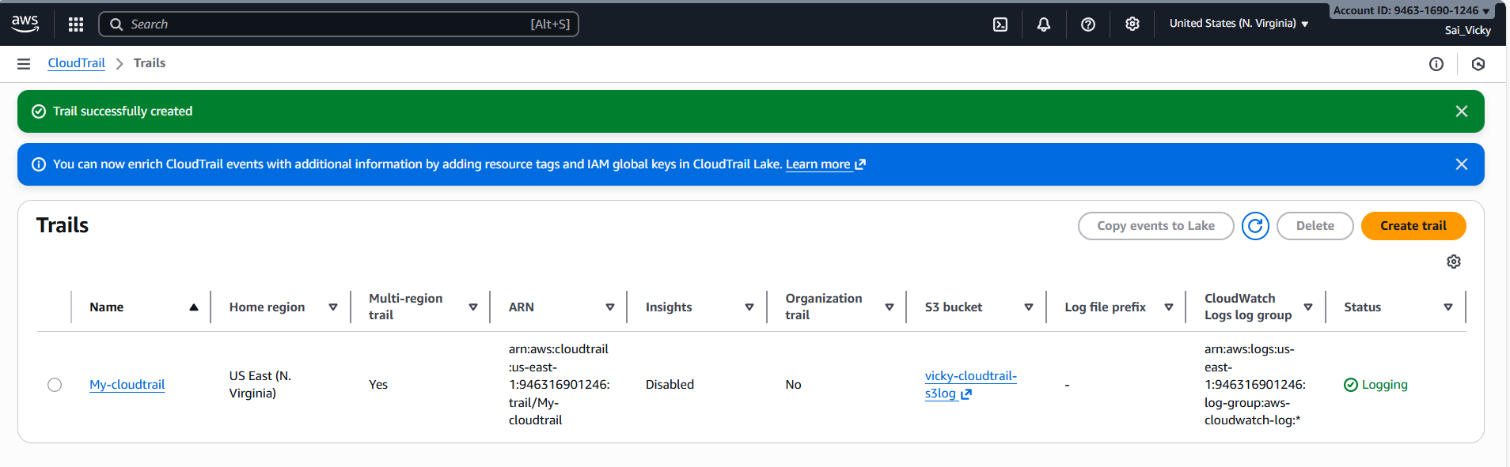
Created CloudTrail monitoring with events in S3 and CloudWatch both.
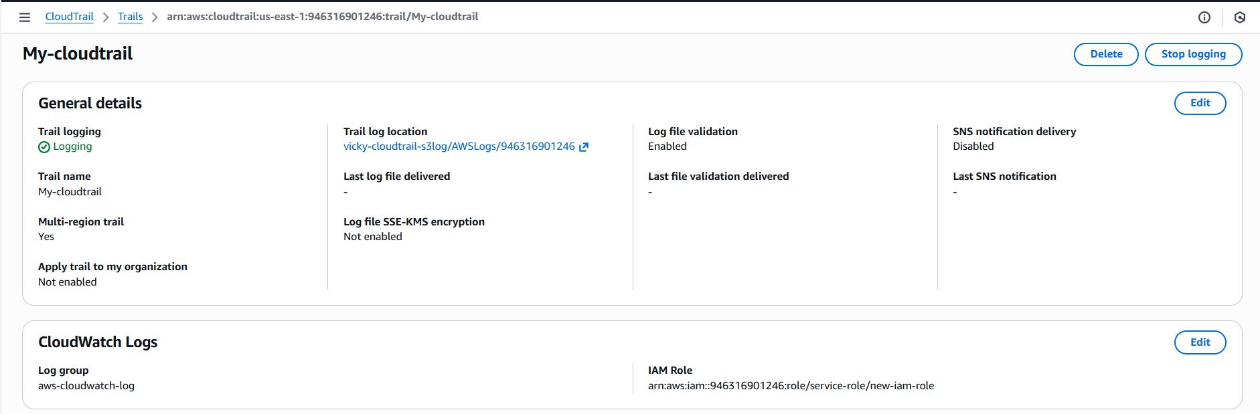
Once CloudTrail created, we can see the logs are created in S3 bucket.
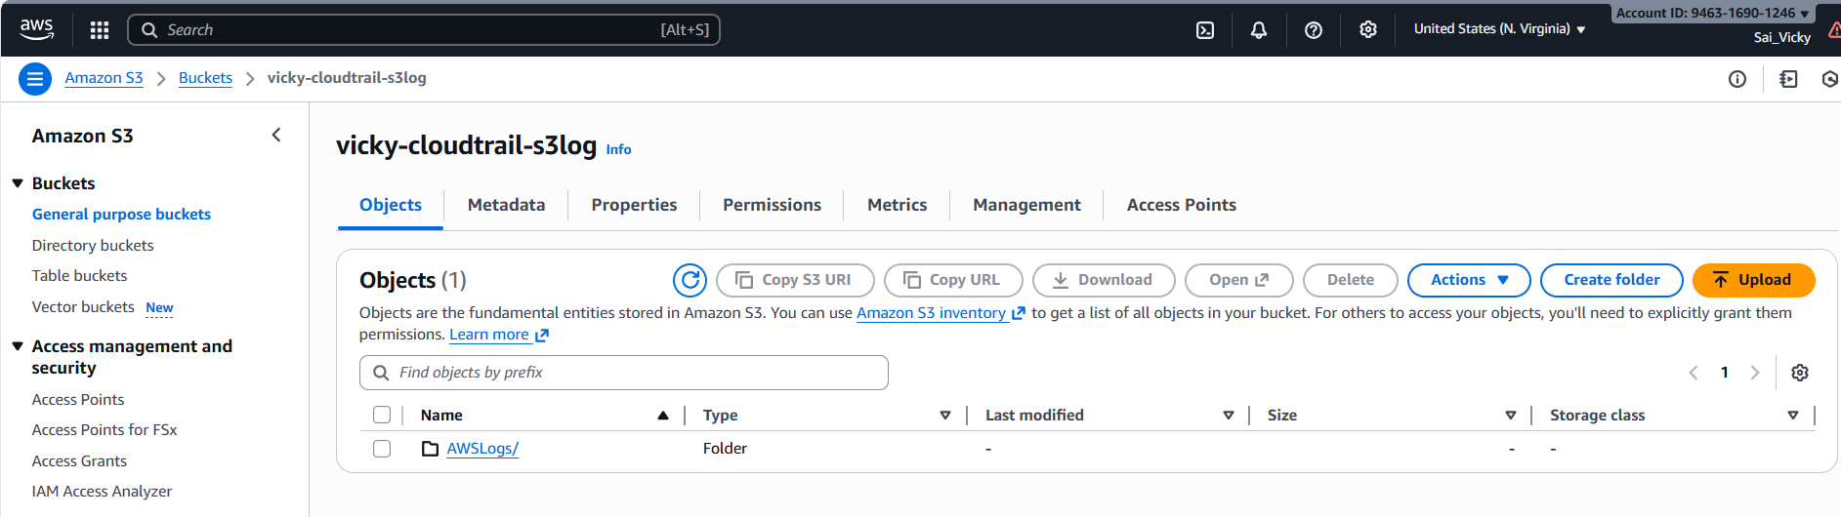

Once CloudTrail created, we can see the logs are created in CloudWatch.
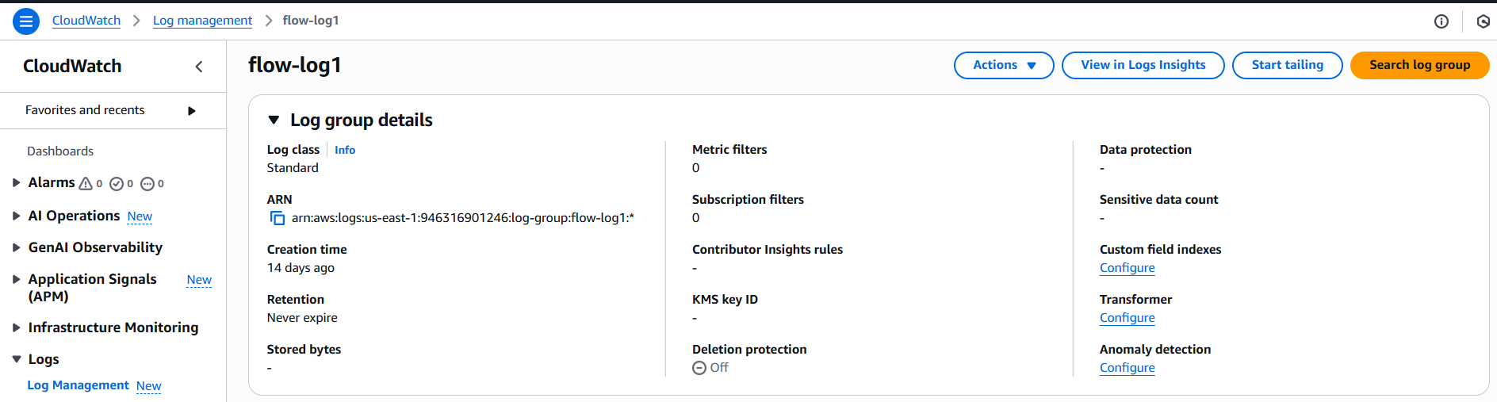

2.Enable SNS for CloudTrail to send alert on email:
Navigated to SNS services in AWS.
Created a new topic in SNS named- My-SNS-topic
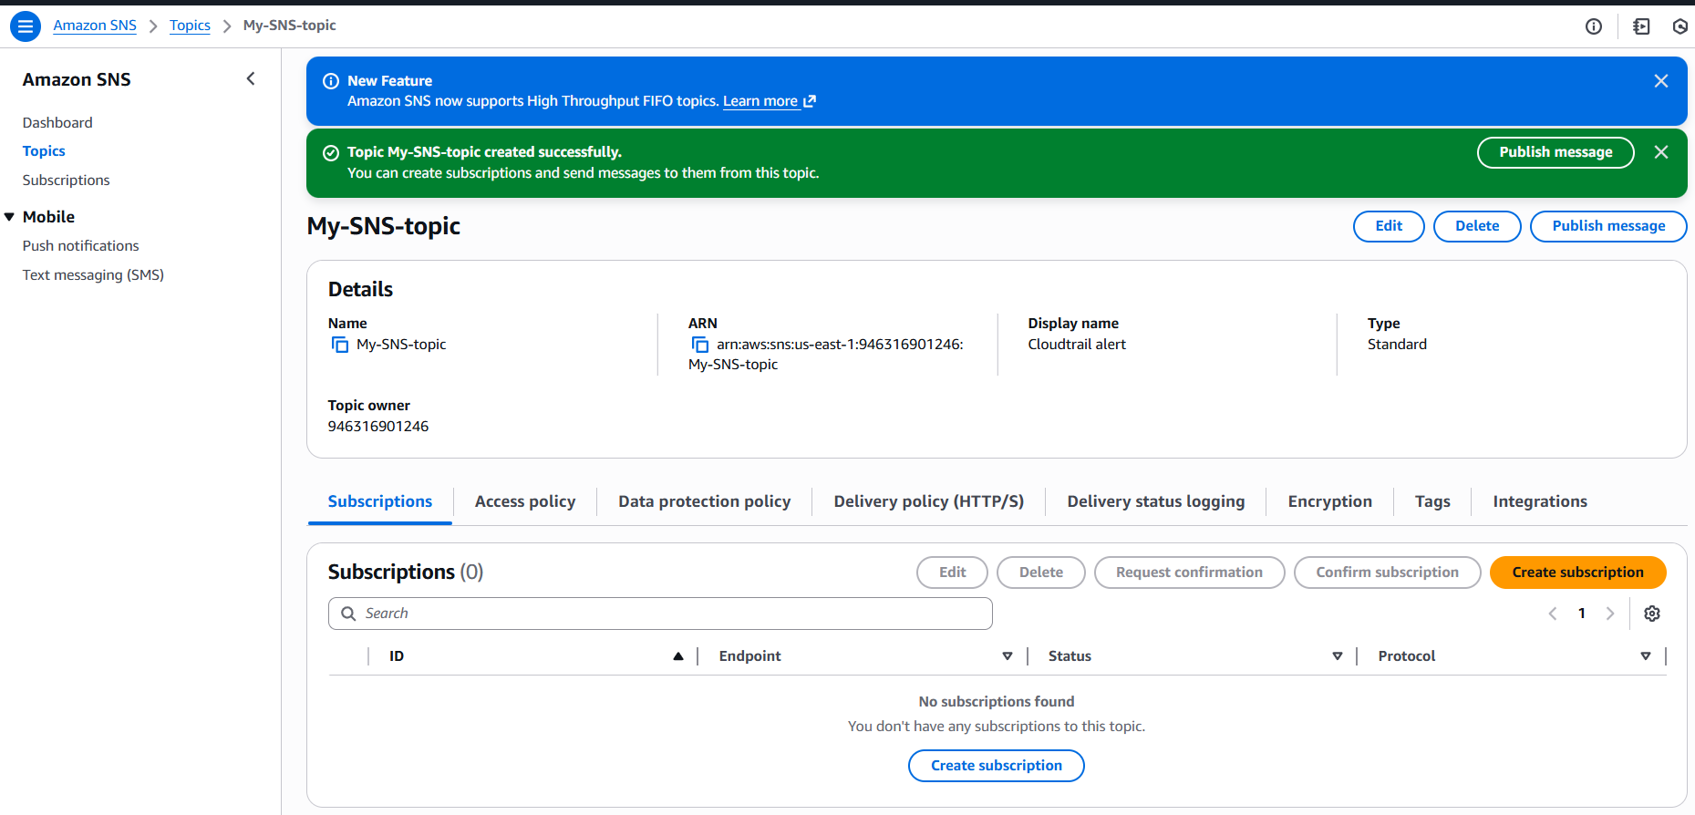
Now, we need to provide subscription to the SNS, what kind of alerts are required.
Here, we are creating e-mail alert for this task, whereas in future, we can modify or create an alert that’s required as per requirement.

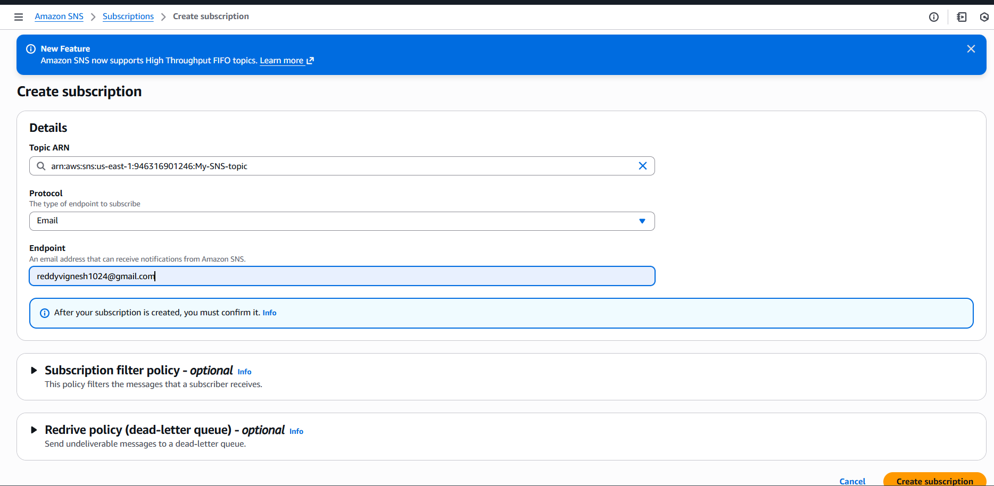
Finally, a subscription has been created in SNS and email alert confirmation is triggered.
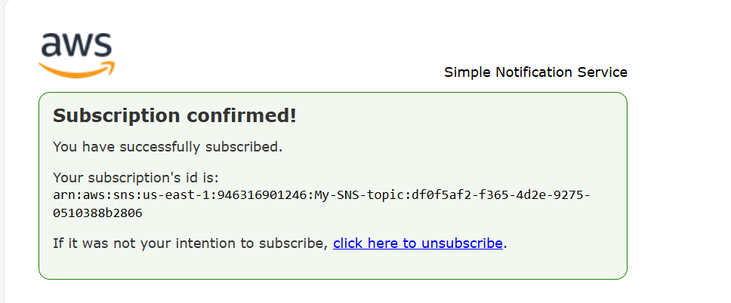

Now, we can see, once email subscription is confirmed, we can see a topic subscription is enabled.
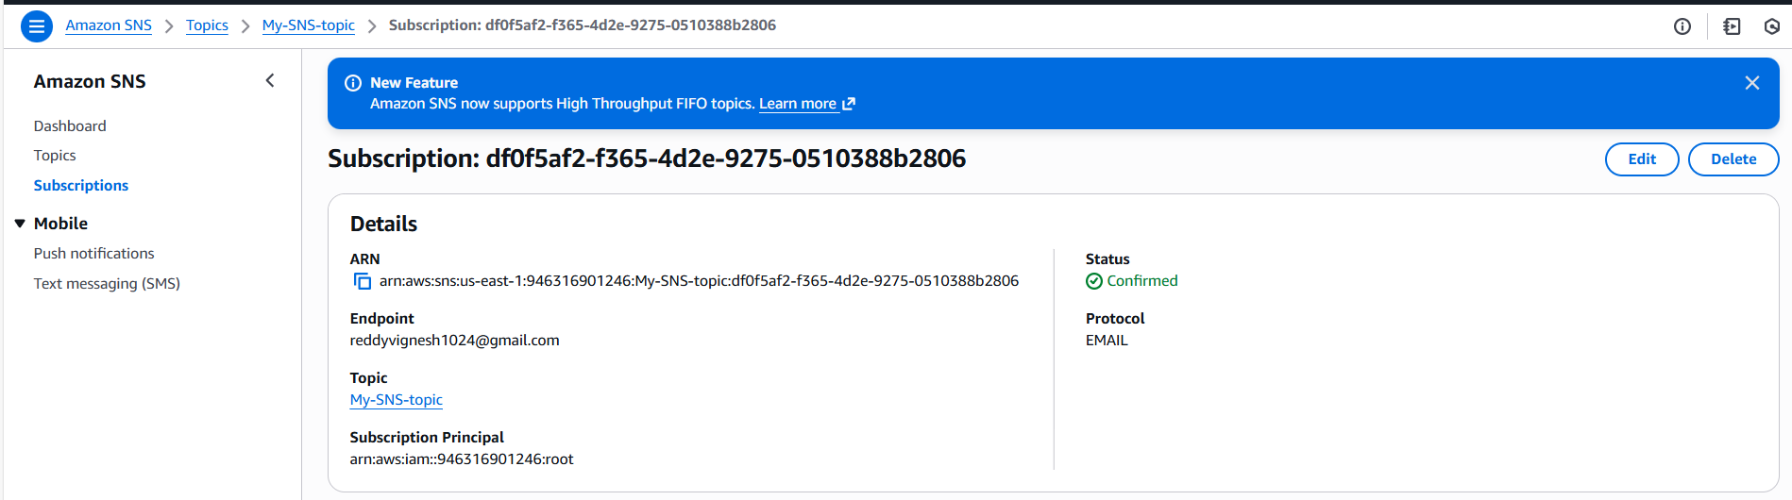

Now, lets create a CloudTrail and attach the SNS created for email alert to get the alerts from CloudTrail logs.
Selected S3 bucket to store the alerts.
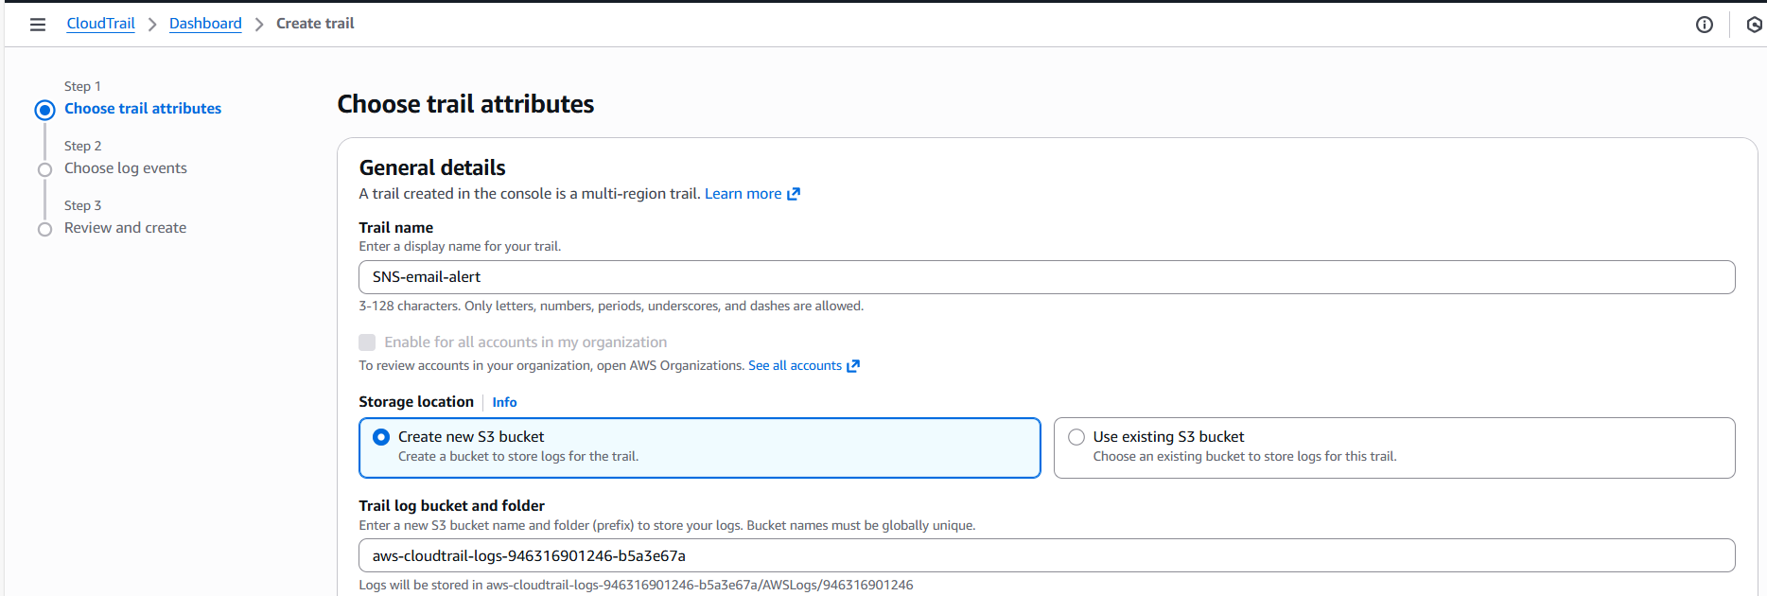
We can see the SNS topic created prior is available now to link with CloudTrail.
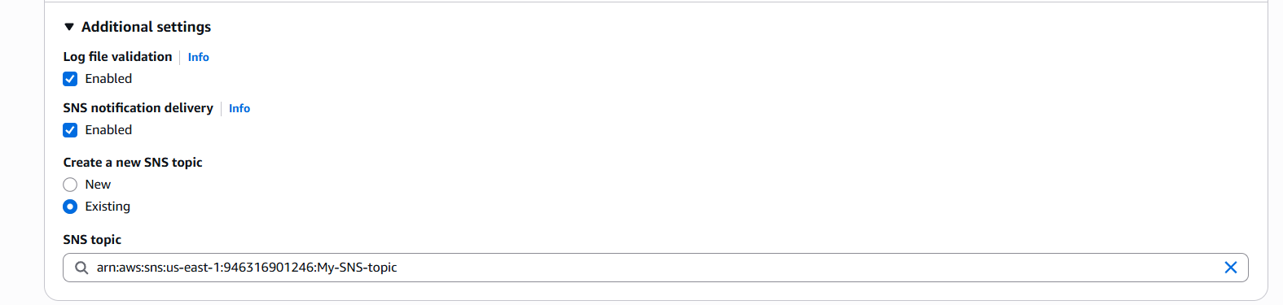
Created new CloudWatch as well to create logs.
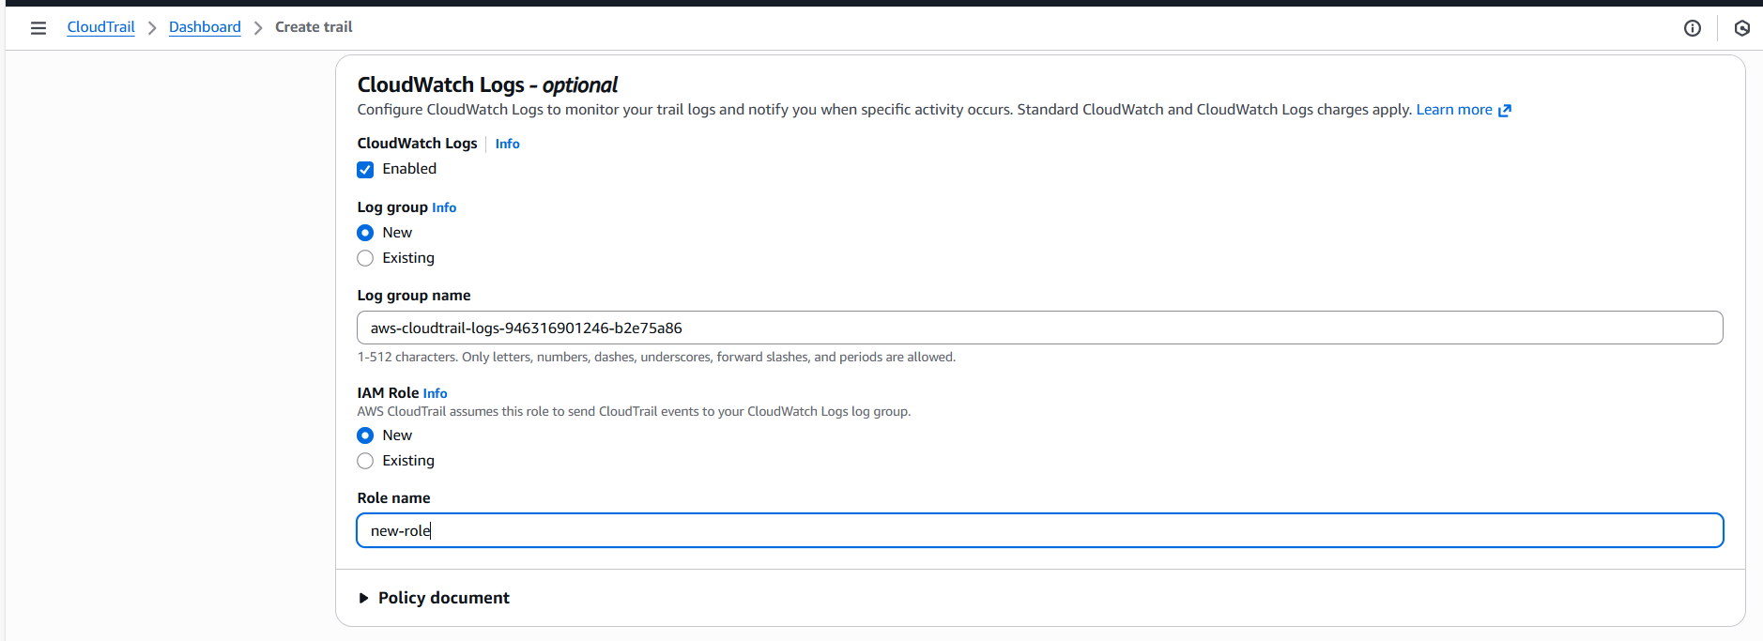
A CloudTrail has been created with SNS.
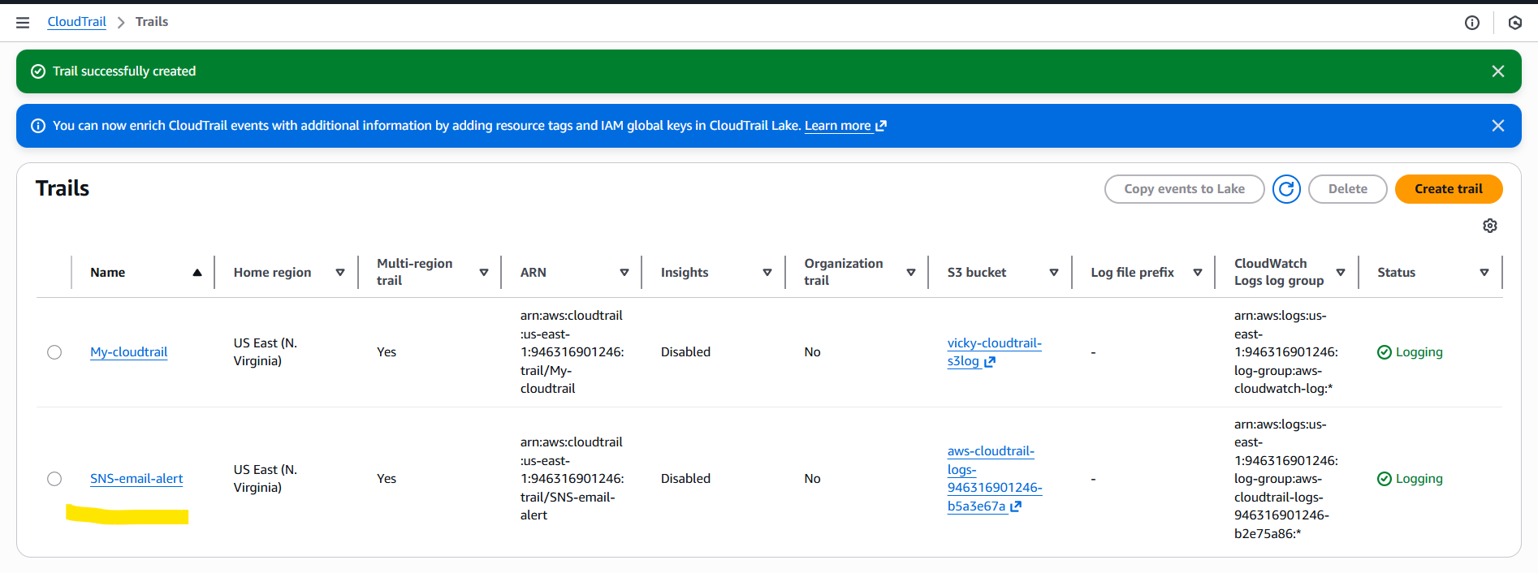

The below are our CloudWatch logs created with SNS.
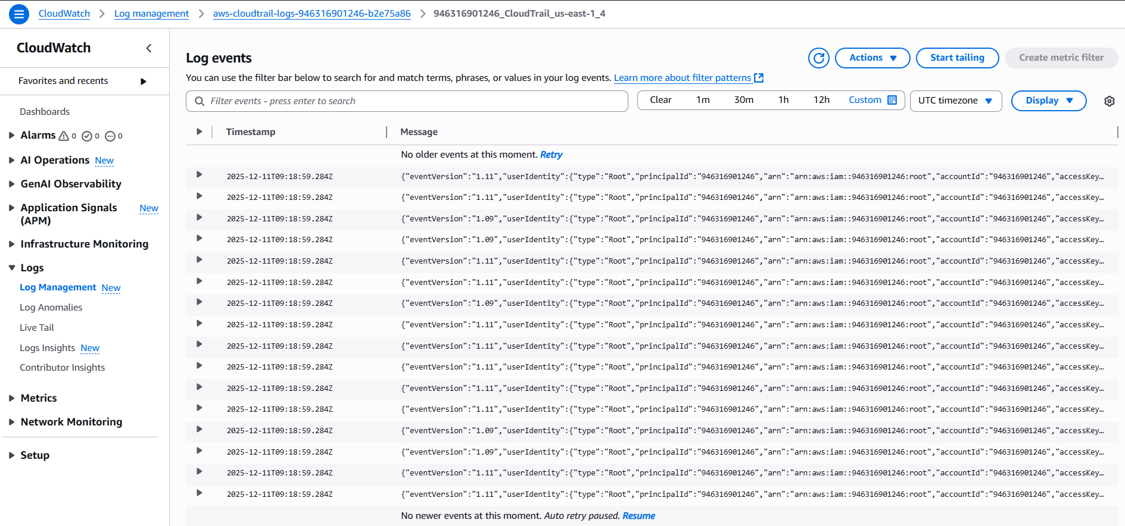
AWS SNS alert is activated and alerts received.
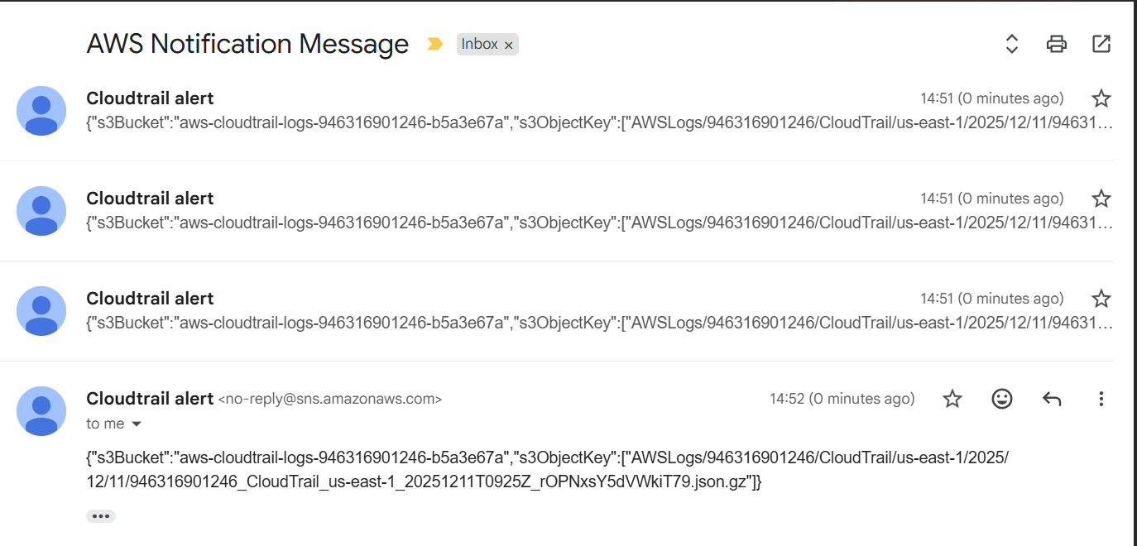

3.Configure cloud watch monitoring and record the CPU utilization and other metrics of ec2:
As per the AWS records ec2 Metrics automatically. We need to enable detailed monitoring, plus watch the metrics.
1st step: Let’s launch a ec2 metrics and monitor the instance for CPU utilization.
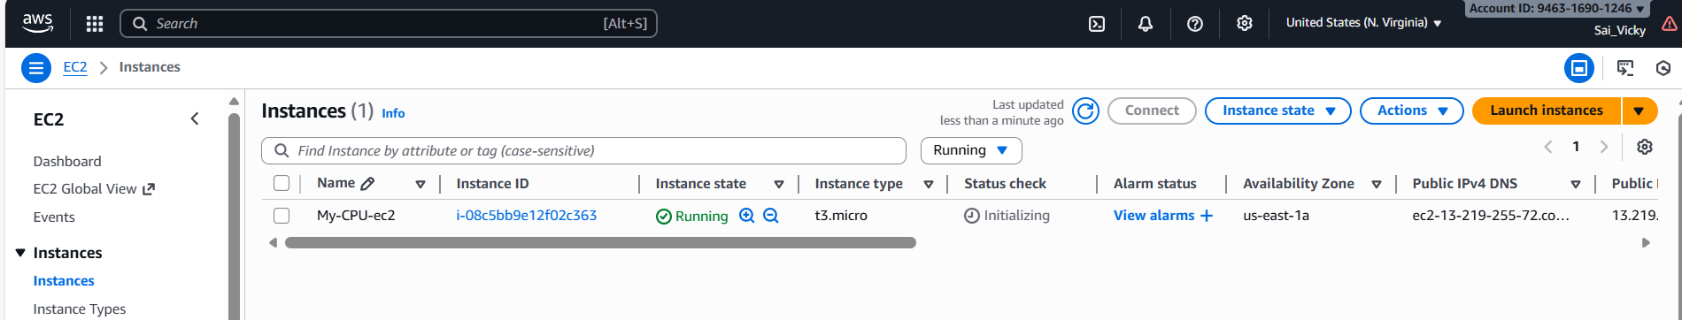
For that, we need to select the instance monitoring and manage detailed monitoring.
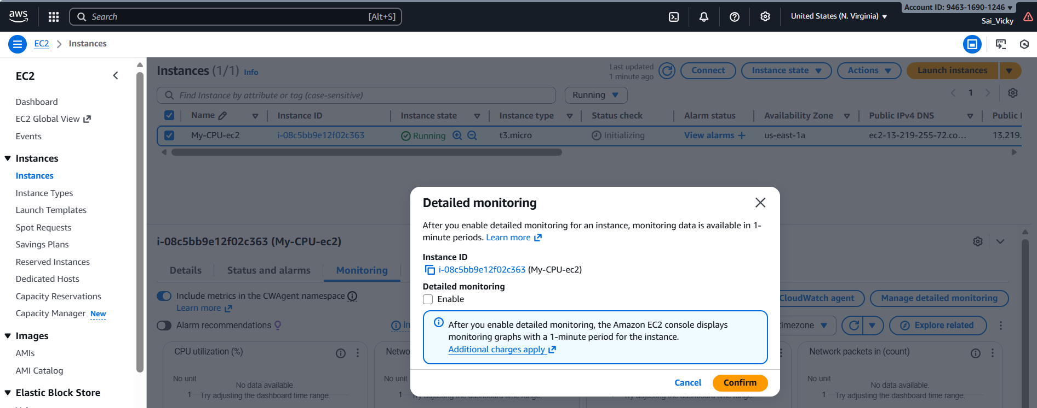
We enabled “Managed Detailed monitoring”.
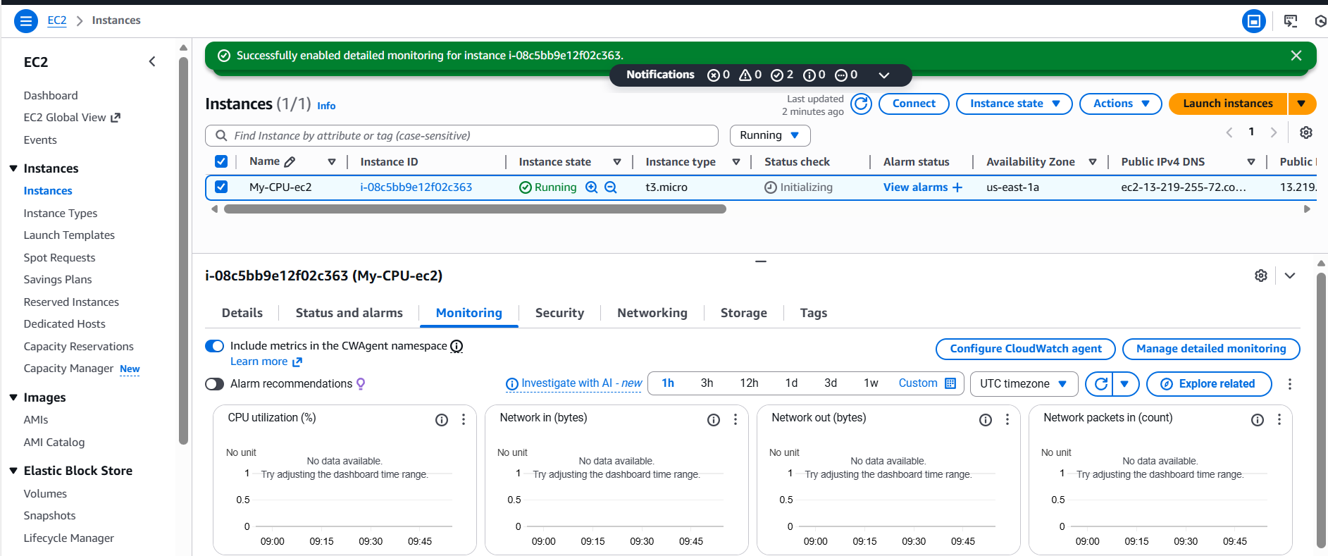

Final step is to add some load to view the CPU utilization. After adding any service inside ec2, we need to check the monitoring of CPU.
By adding some fake load, we might be able to see the CPU utilization above certain percentage to confirm if the CloudWatch is working perfectly fine.
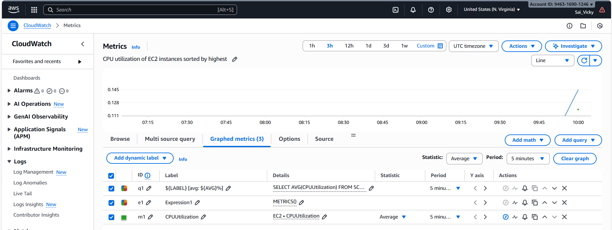
Create a custom Dashboard with Number- percentage.
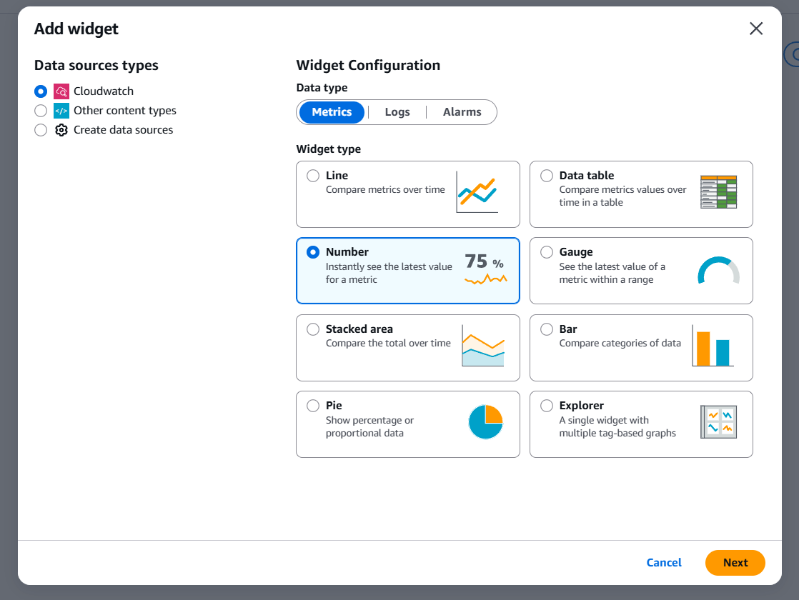
Using Top command- verified how much percentage did ec2- CPU utilization used.
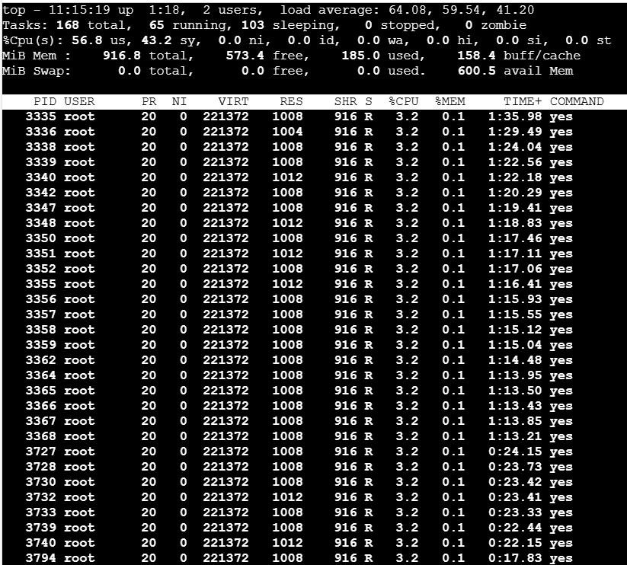
4.Create one alarm to send alert to email if the CPU utilization is more than 70 percent:
Let’s begin creating alarm as 1st step.
Navigate to alarm and create one.
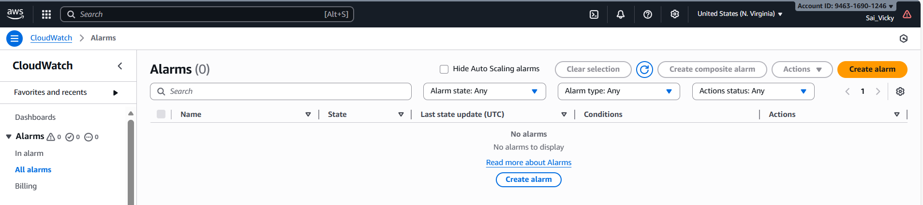
Select ec2 from metrics.
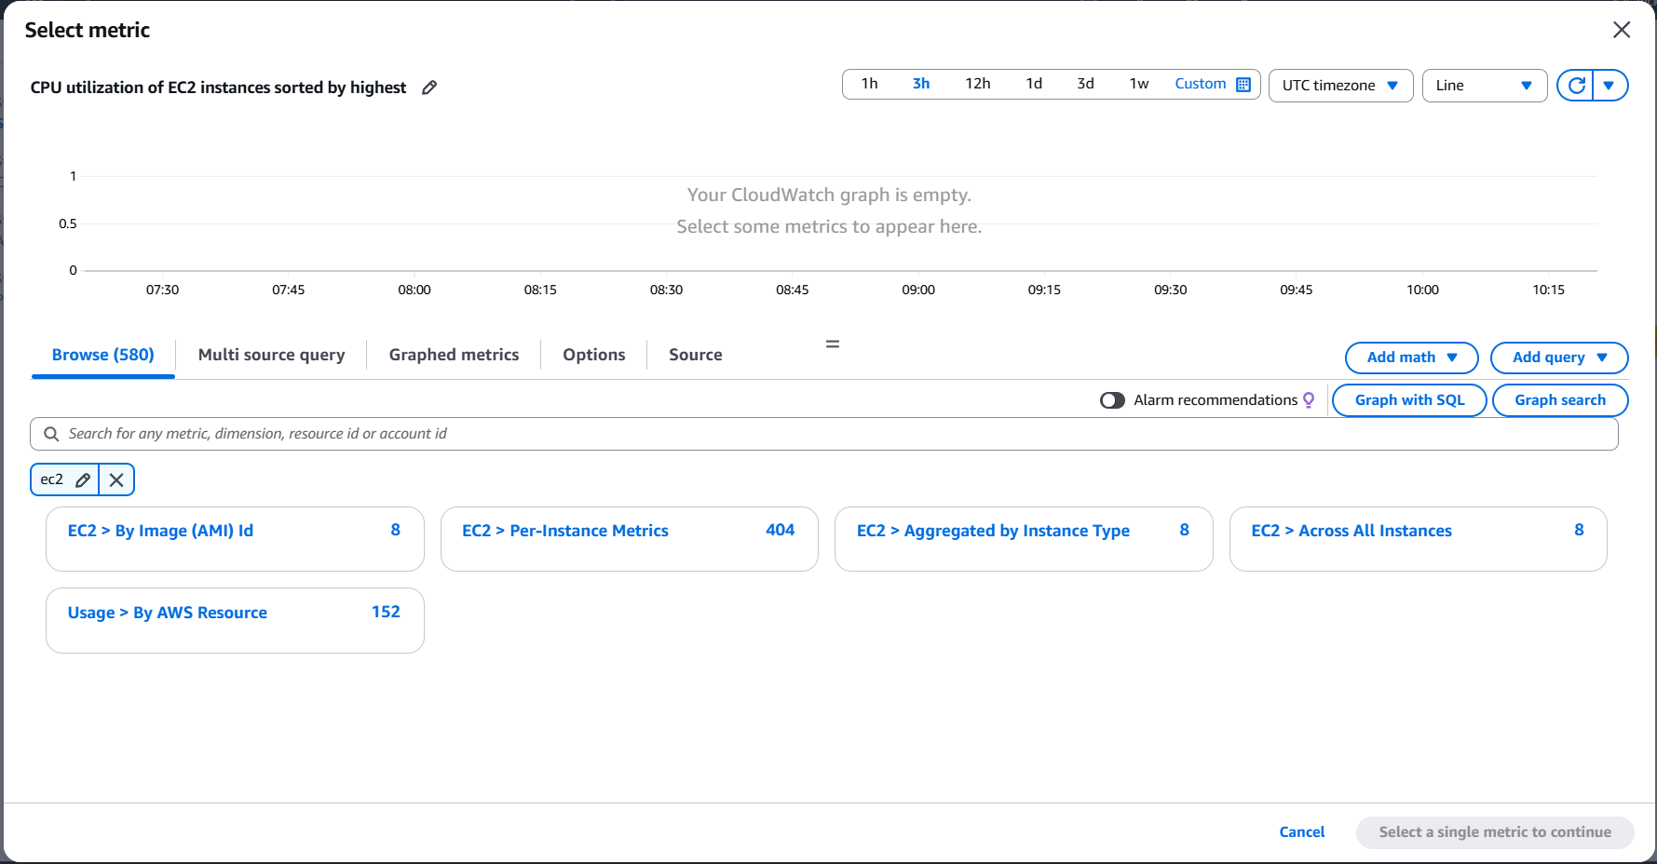
Setting up an in alarm for SNS notification to get alerts on Gmail.
Selected an existing SNS topic.
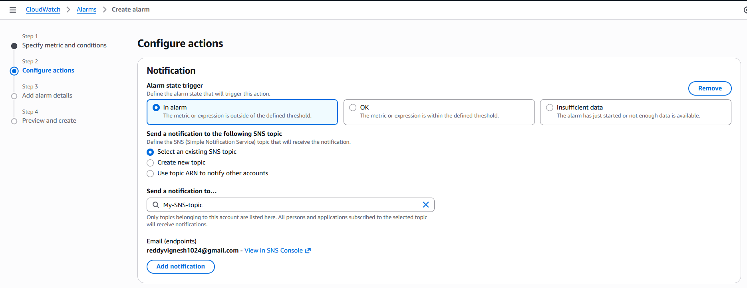
Named the alarm according to the task- Monitoring alert.
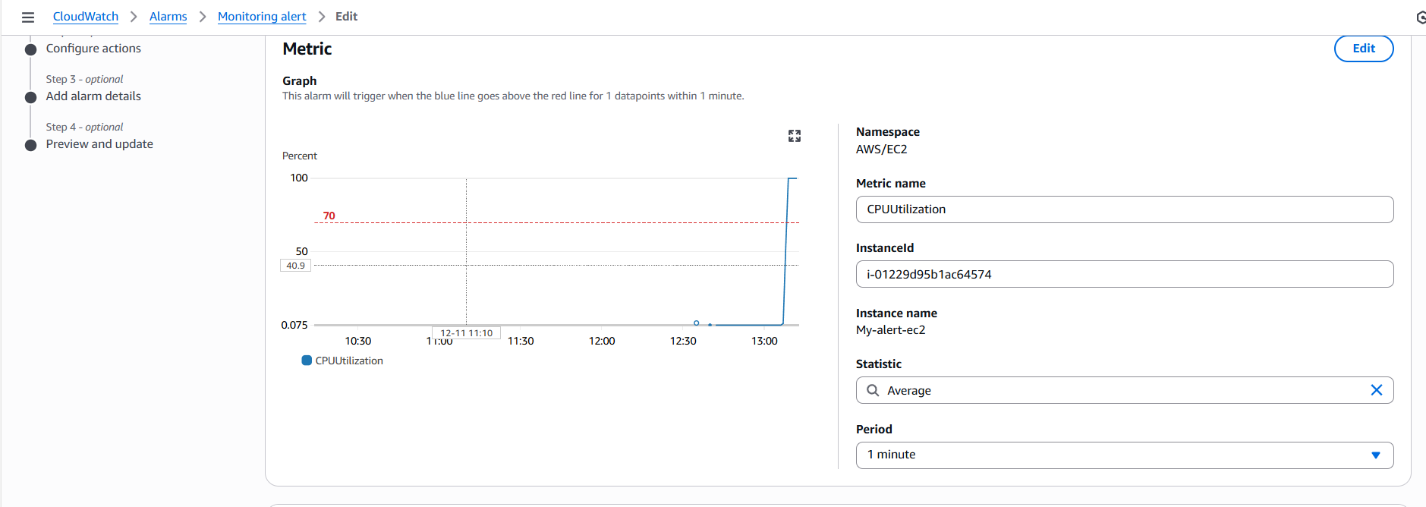

Condition for the CPU- utilization is set when “Greater than 70%”
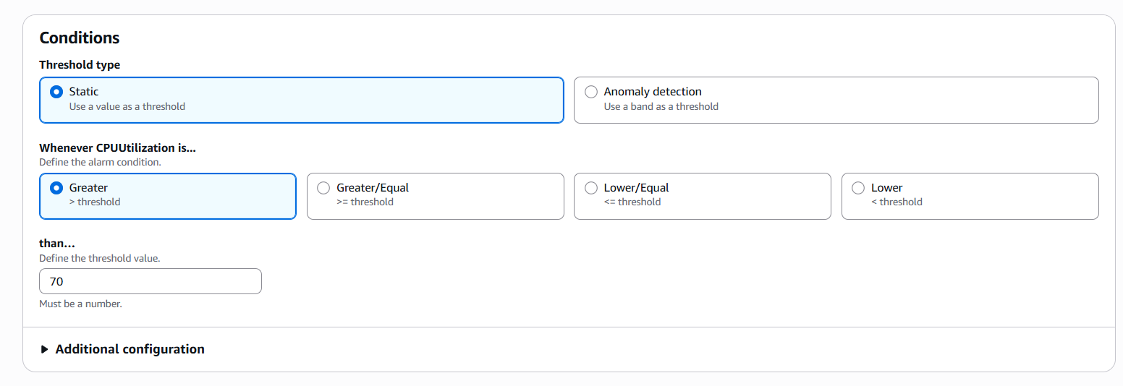
Selected existing SNS alert with email alert.
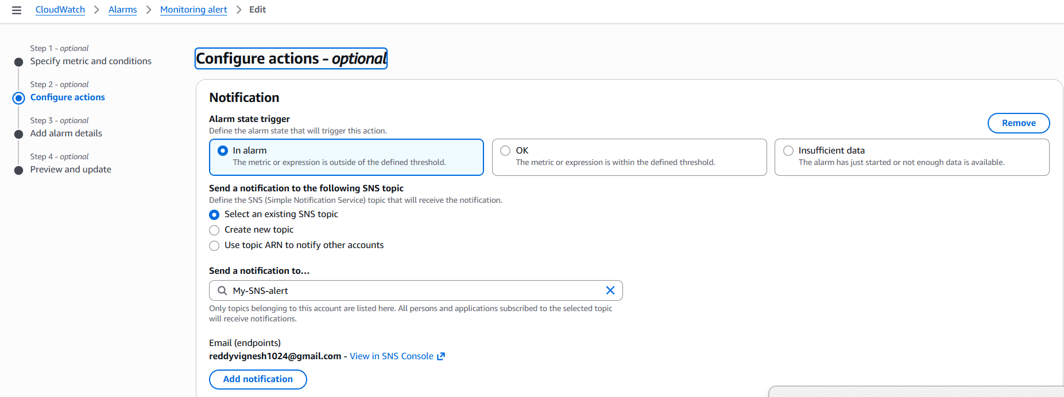
Created alarm successfully.
Connected to the ec2 instance and faked CPU utilization. Immediately, we received alarm alert in CloudWatch and received an SNS alert to my email (attached below).
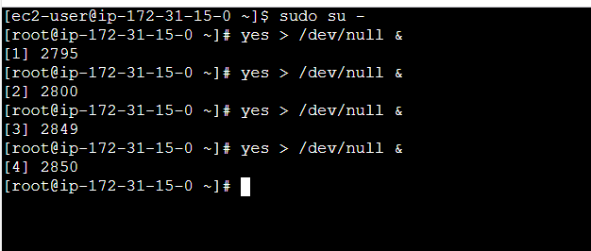
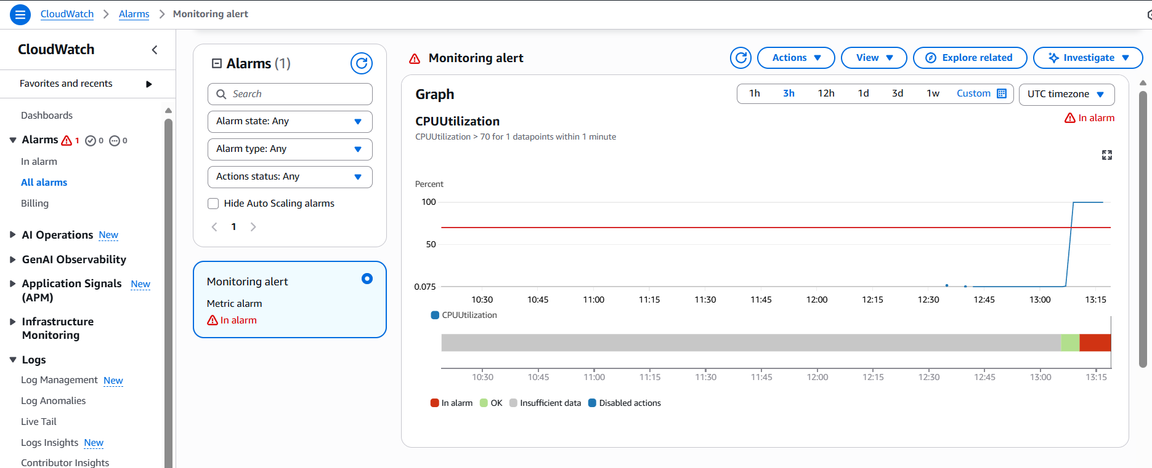

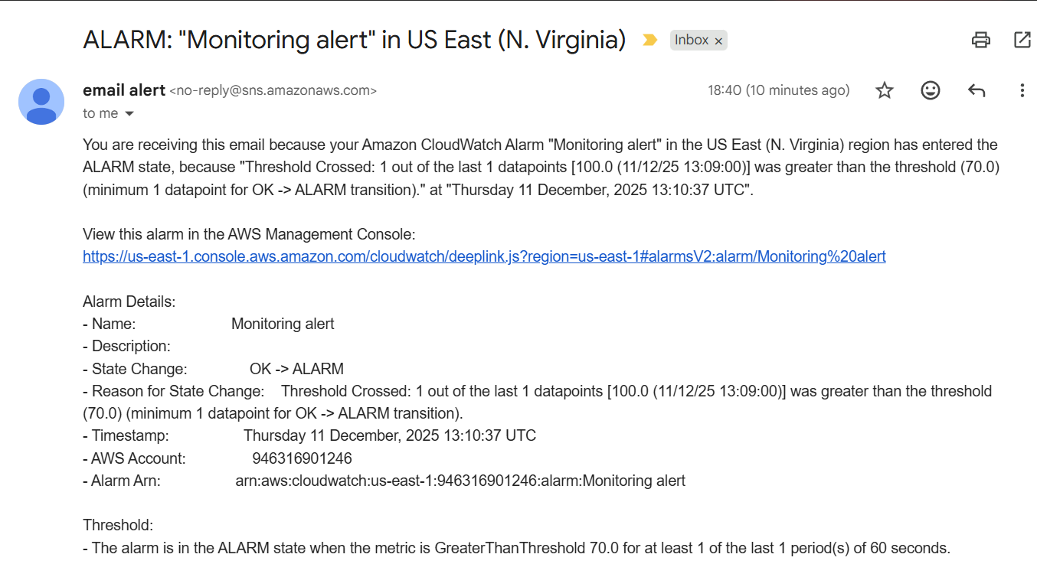

5.Create Dashboard and monitor tomcat service whether its running or not and send the alert:

Launched a new ec2 named- Tomcat-ec2.
Connect to ec2 console and install packages using command- sudo yum update -y and install java using command- yum install java -y command.

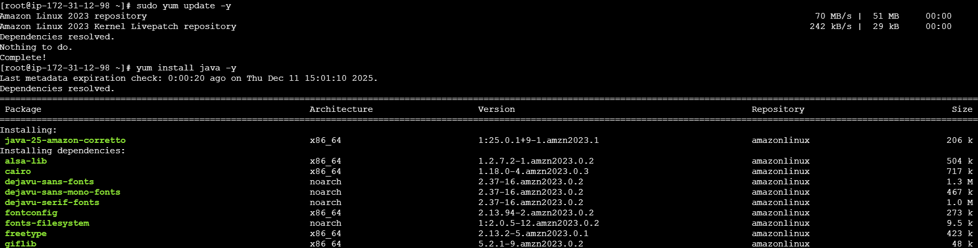
Install Tomcat by using wget command and execute.
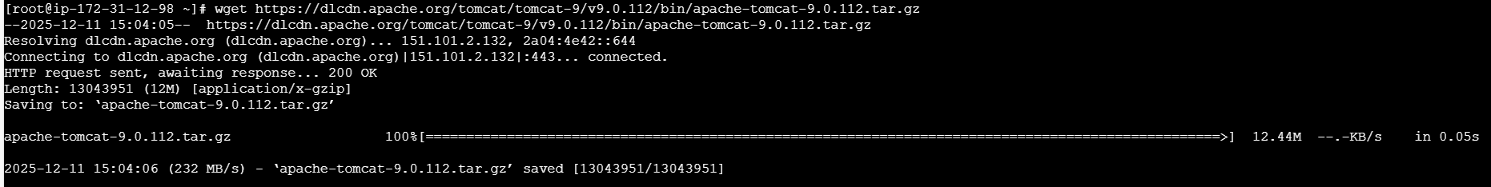
Extract the file using tar xvf command
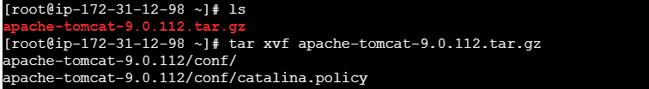
Now cd to apache-tomcat
Now cd to bin and execute Tomcat to start
